PENETRATION TESTING LAB REPORT

Reflected Cross-Site Scripting (XSS)
PortSwigger Web Security Academy | Apprentice Lab

1. Executive Summary
A reflected Cross-Site Scripting (XSS) vulnerability was successfully demonstrated in the PortSwigger Web Security Academy lab, “Reflected XSS into HTML context with nothing encoded.” The search functionality reflected user-controlled input into the returned HTML without encoding it for the HTML context. A JavaScript alert was triggered in the browser, and the lab displayed its successful-completion confirmation.

2. Lab Information and Scope
Platform: PortSwigger Web Security Academy
Lab: Reflected XSS into HTML context with nothing encoded
Vulnerability class: Cross-Site Scripting (XSS) — Reflected
Difficulty: Apprentice
Target: The assigned PortSwigger lab instance (temporary lab hostname)
Testing scope: The intentionally vulnerable lab application only
Testing was performed in the authorised, intentionally vulnerable training environment. No third-party system was targeted.

3. Vulnerability Overview
Reflected XSS occurs when an application takes untrusted input from a request and includes it in the immediate response in a way that the browser interprets as executable markup or script. In this lab, the search term was reflected into the page's HTML content. Because the input was not safely encoded for that output context, attacker-controlled markup could be interpreted by the browser rather than displayed as plain text.

4. Methodology and Findings
- Opened the assigned PortSwigger lab and identified the blog search feature.
- Submitted the benign search term “hello” to observe how the application handled search input.
- Inspected the request and response using Burp Suite. The request showed the search value in the URL query parameter: GET /?search=hello.
- Observed that the response included the search term in the results heading and in the search input's value attribute. The supplied response screenshot shows the term reflected in the HTML.
- Tested JavaScript execution with the lab payload <script>alert(1)</script>. The browser displayed an alert containing “1”.
- Confirmed successful exploitation when PortSwigger displayed “Congratulations, you solved the lab!”

5. Proof of Concept
Observed benign request: GET /?search=hello
Successful test payload: <script>alert(1)</script>
The alert dialog is evidence that the browser executed JavaScript in the context of the lab page. The submitted screenshots do not include a separate raw HTTP request containing the final payload; the payload above is recorded from the successful lab procedure, while the Burp screenshot documents the baseline reflection of the benign search term.

6. Impact
A successful reflected XSS flaw can allow an attacker to execute script in a victim's browser under the vulnerable site's origin when the victim is induced to visit a crafted URL or otherwise submit attacker-controlled input. Depending on application context and browser-side protections, this may enable page manipulation, phishing, access to information available to page scripts, or actions performed through the victim's authenticated session. The lab demonstrates script execution; it does not establish that every listed impact is achievable in this specific application.

7. Remediation
- Apply context-sensitive output encoding whenever untrusted data is inserted into HTML, attributes, JavaScript, CSS or URL contexts.
- Prefer safe templating mechanisms that automatically encode output; avoid inserting untrusted data through unsafe HTML sinks.
- Where HTML input is genuinely required, use a well-maintained allowlist-based HTML sanitiser appropriate to the intended context.
- Use safe DOM APIs such as textContent instead of assigning untrusted strings to innerHTML.
- Deploy Content Security Policy (CSP) as a defence-in-depth measure; do not treat CSP as a substitute for correct output handling.
- Add regression tests covering reflected input in every relevant output context.

8. Evidence
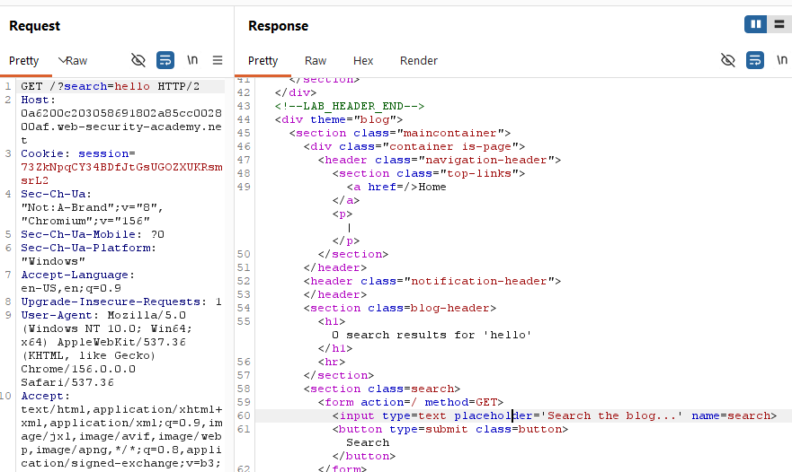
Figure 1. Burp Suite request and response: the benign search term hello is submitted in the search parameter and reflected in the HTML response.
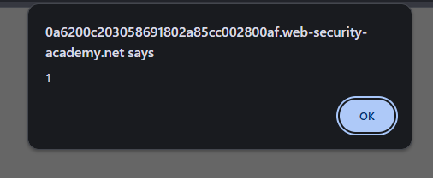
Figure 2. Browser alert displaying 1, demonstrating JavaScript execution in the lab.

Figure 3. PortSwigger confirmation that the lab was solved.

9. Conclusion
The lab demonstrated reflected XSS caused by unsafe reflection of search input into an HTML response. JavaScript execution was confirmed by the browser alert, and the platform confirmed that the lab was solved. The key defensive lesson is to encode untrusted output for its exact rendering context and to avoid unsafe DOM or HTML insertion patterns.

10. Limitations and Reporting Notes
This is a controlled training-lab result, not an assessment of a production application. The screenshots supplied establish the benign request/response reflection, browser alert and lab completion. They do not show a full raw request/response pair containing the final XSS payload, so that specific network-level evidence has not been claimed.
CVSS: Not assigned. A defensible score requires application-specific exploitability and impact context; the lab's training result alone is insufficient for a production severity rating.
CVE: Not applicable/identified for this deliberately constructed lab exercise.

